Docker Swarm Introduction

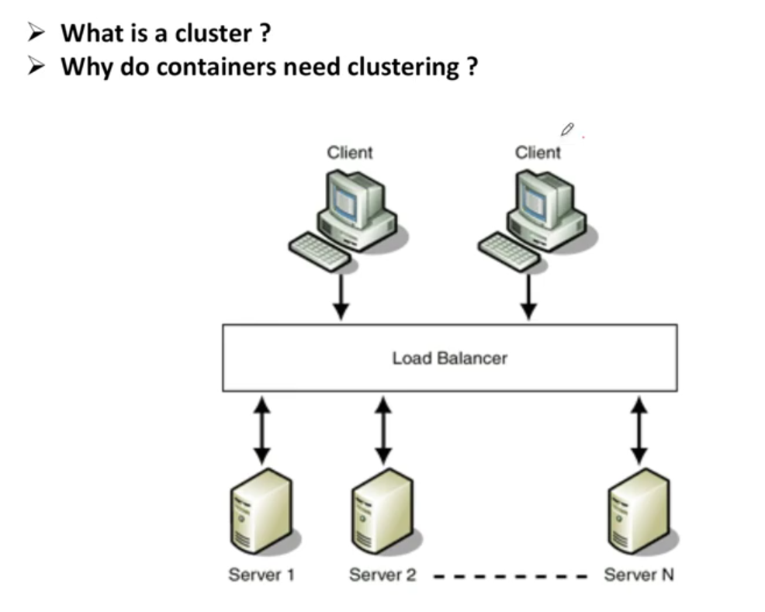

This Is Docker Orchestration or Clustering

What is clustering

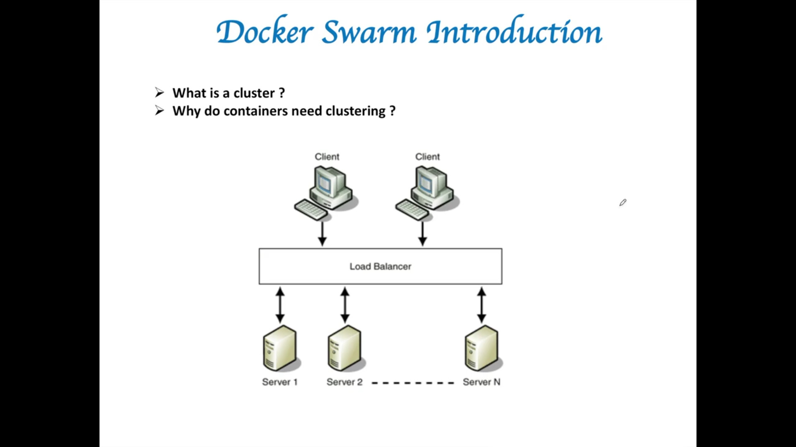

Load balancer will throw req to any underlying servers based on some algorithm.. that can be Round Robin.. Load balance will check what is the current weight and current utilization and

where ever utilization is least it will send request to that server

How it help us?

We are optimizing load on these servers. No server is overloaded and under utilized

Is any server goes down for any reason that particular request routed to diff underlying servers

This Is called Clustering. Cluster main intention is to make end user your services are always up and running to provide high availability

Diff servers on which you have hosted diff applications and need to provide services and these services should be up and running all the time

**Why do containers need clustering?**

**Container also trying to solve the same problem that apps should be up and running al the time**

**We will take the applications and put them in containers and end reason is high availability  
so you need some orchestration and clustering for these containers**

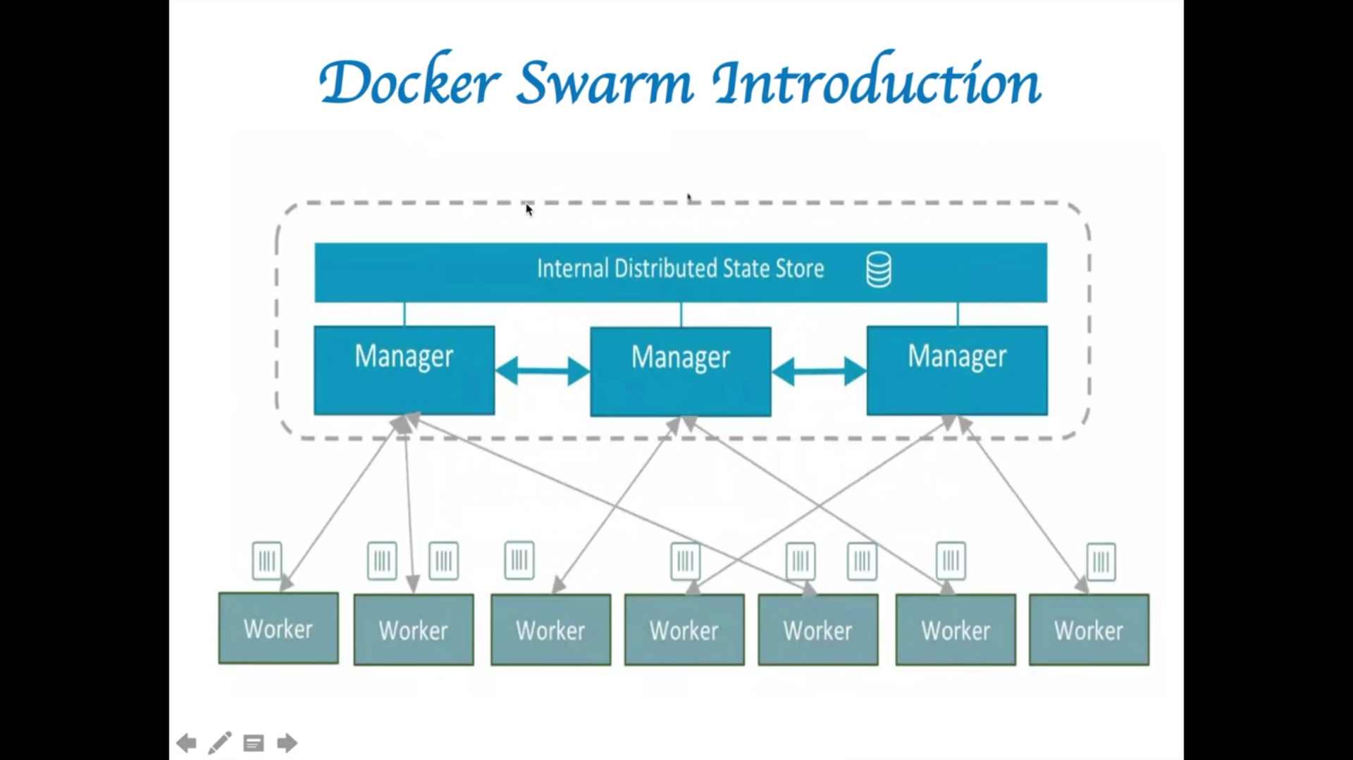

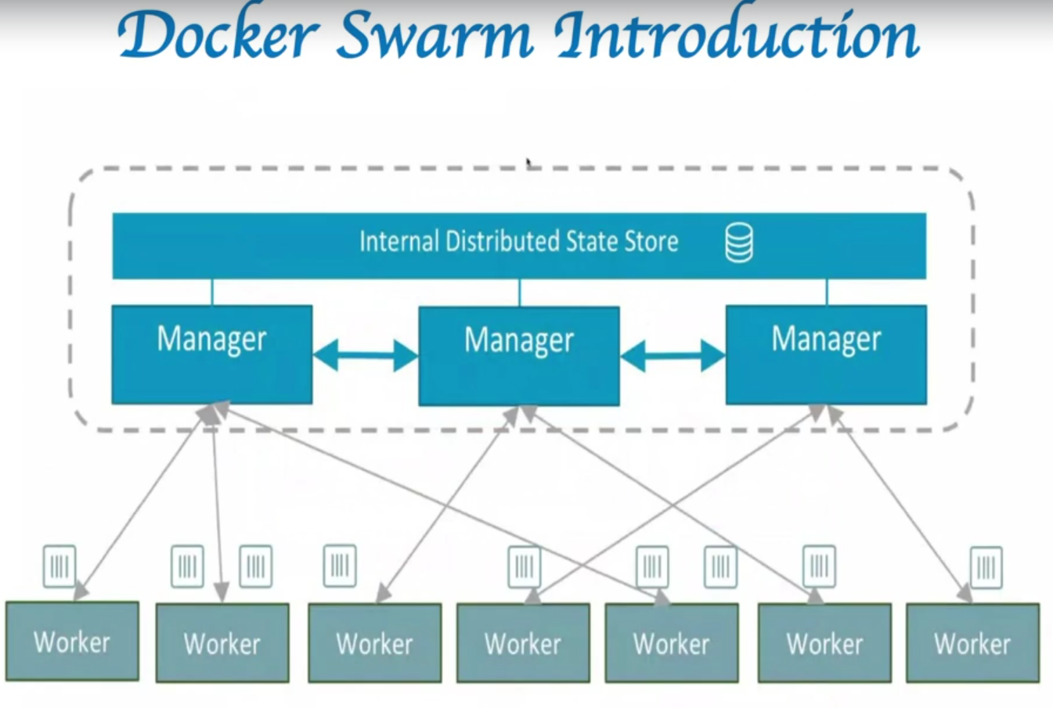

**Docker swarm is nothing but orchestrator for containers**

**Orchestrator is a software that will ensure application should be always up and running**

**For ex: if your appl need 7 containers . that software should ensure all the time 7 containers should be u p and running**

**If 1 containers goes down or fails….it is role of software to ensure that one more container with same kind of specification as that one that went down should be brought up**

**End result is all your services are up and running**

**So that is orchestrator would do.**

**Docker swarm contains 2 diff kind of machines**

**One is manager and second is worker node**

**Manager will take so many decisions like resource allocation , where to put containers based on some alogos**

**If 1 manager goes down , it should not impact cluster so we have more than 1 manager min 3**

**Based on raft algorithm**

**This algo take care of even 1 manager goes down. Another manager takes over the repsonsibilities**

**Leader is the one which gives commands and other managers in sync with the leader**

**Here 1 Manger is 1 VM and 1 worker is another VM and both have individual responsibilities**

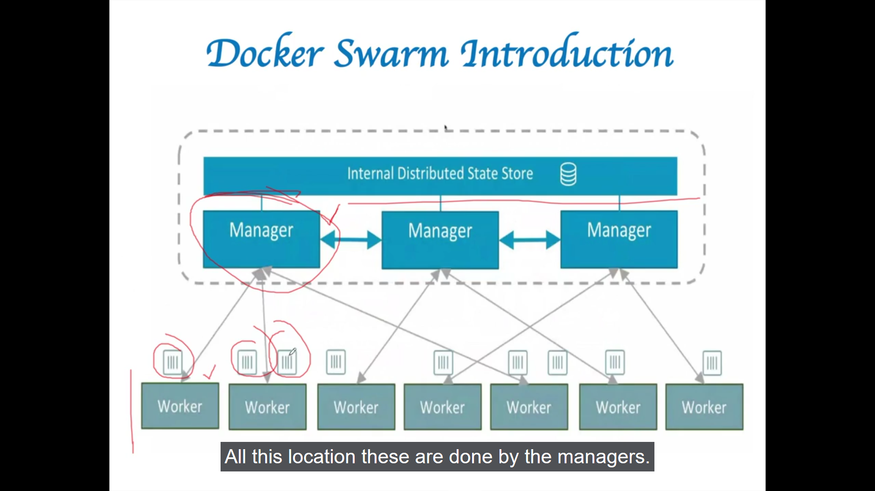

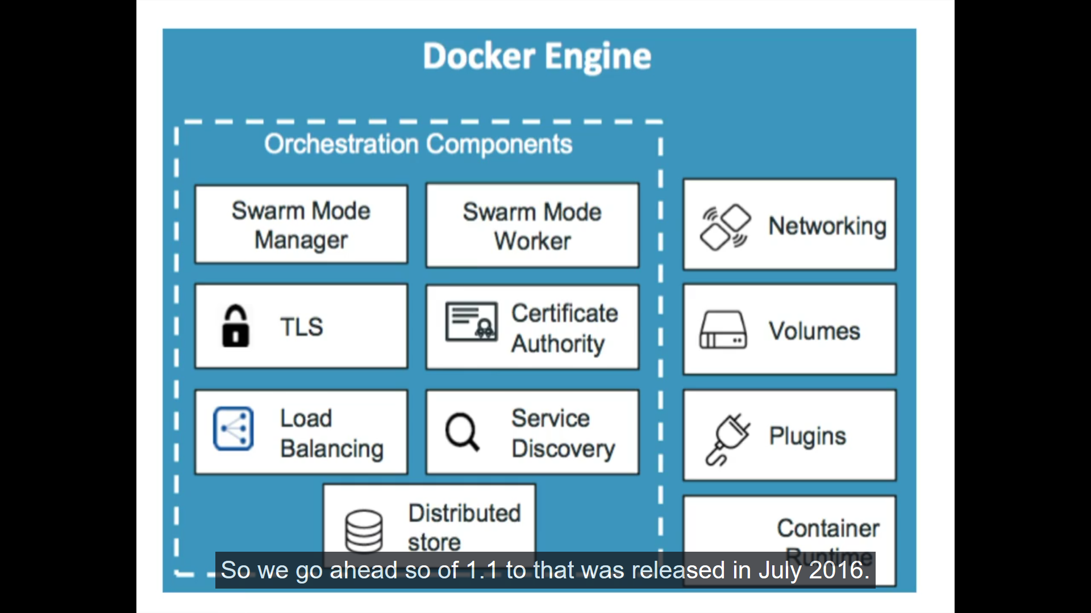

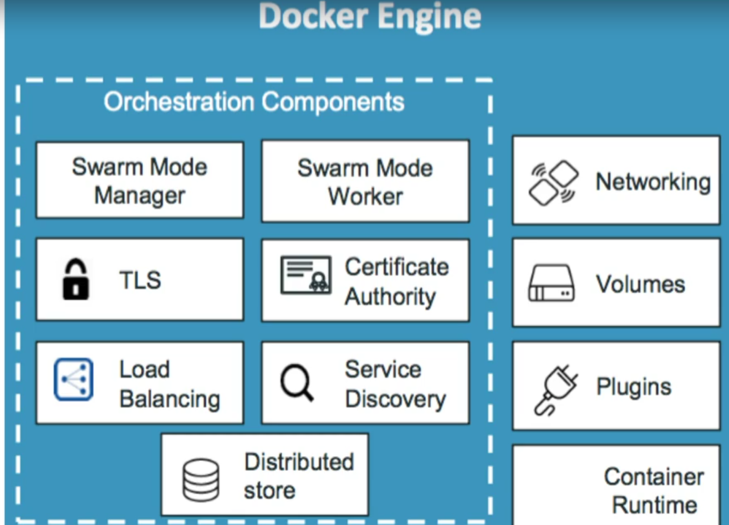

**Any info exchange will happen n secure manner with TLS**

**Certificates provided by inbuild and can be changed for n num of days**

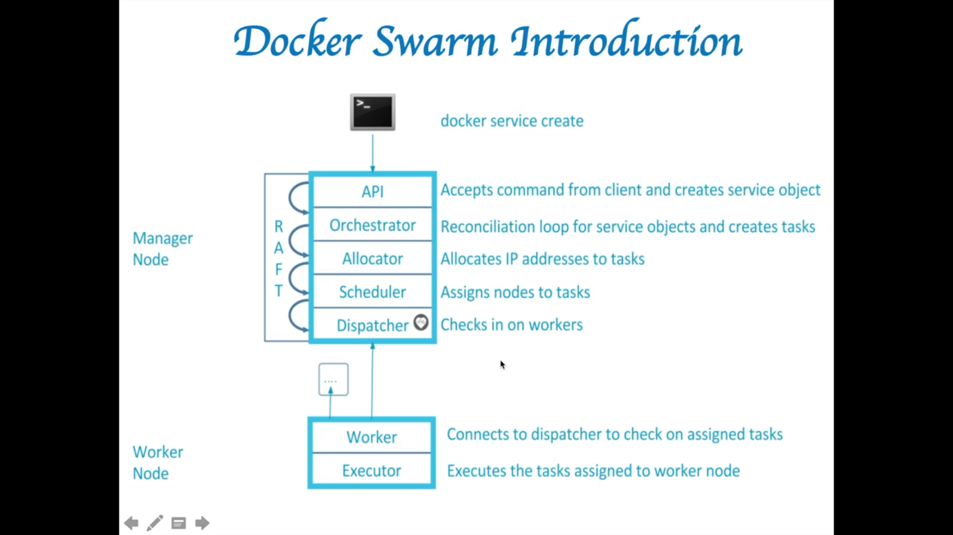

**How manager and worker work**

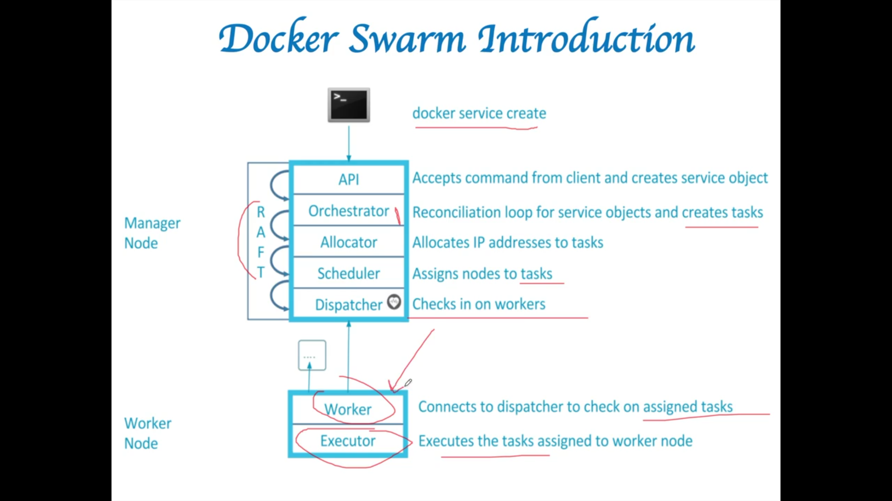

**02**

**Start 5 nodes on Labs**

[https://labs.play-with-docker.com](https://labs.play-with-docker.com/)

**enter docker swarm command**

**docker swarm**

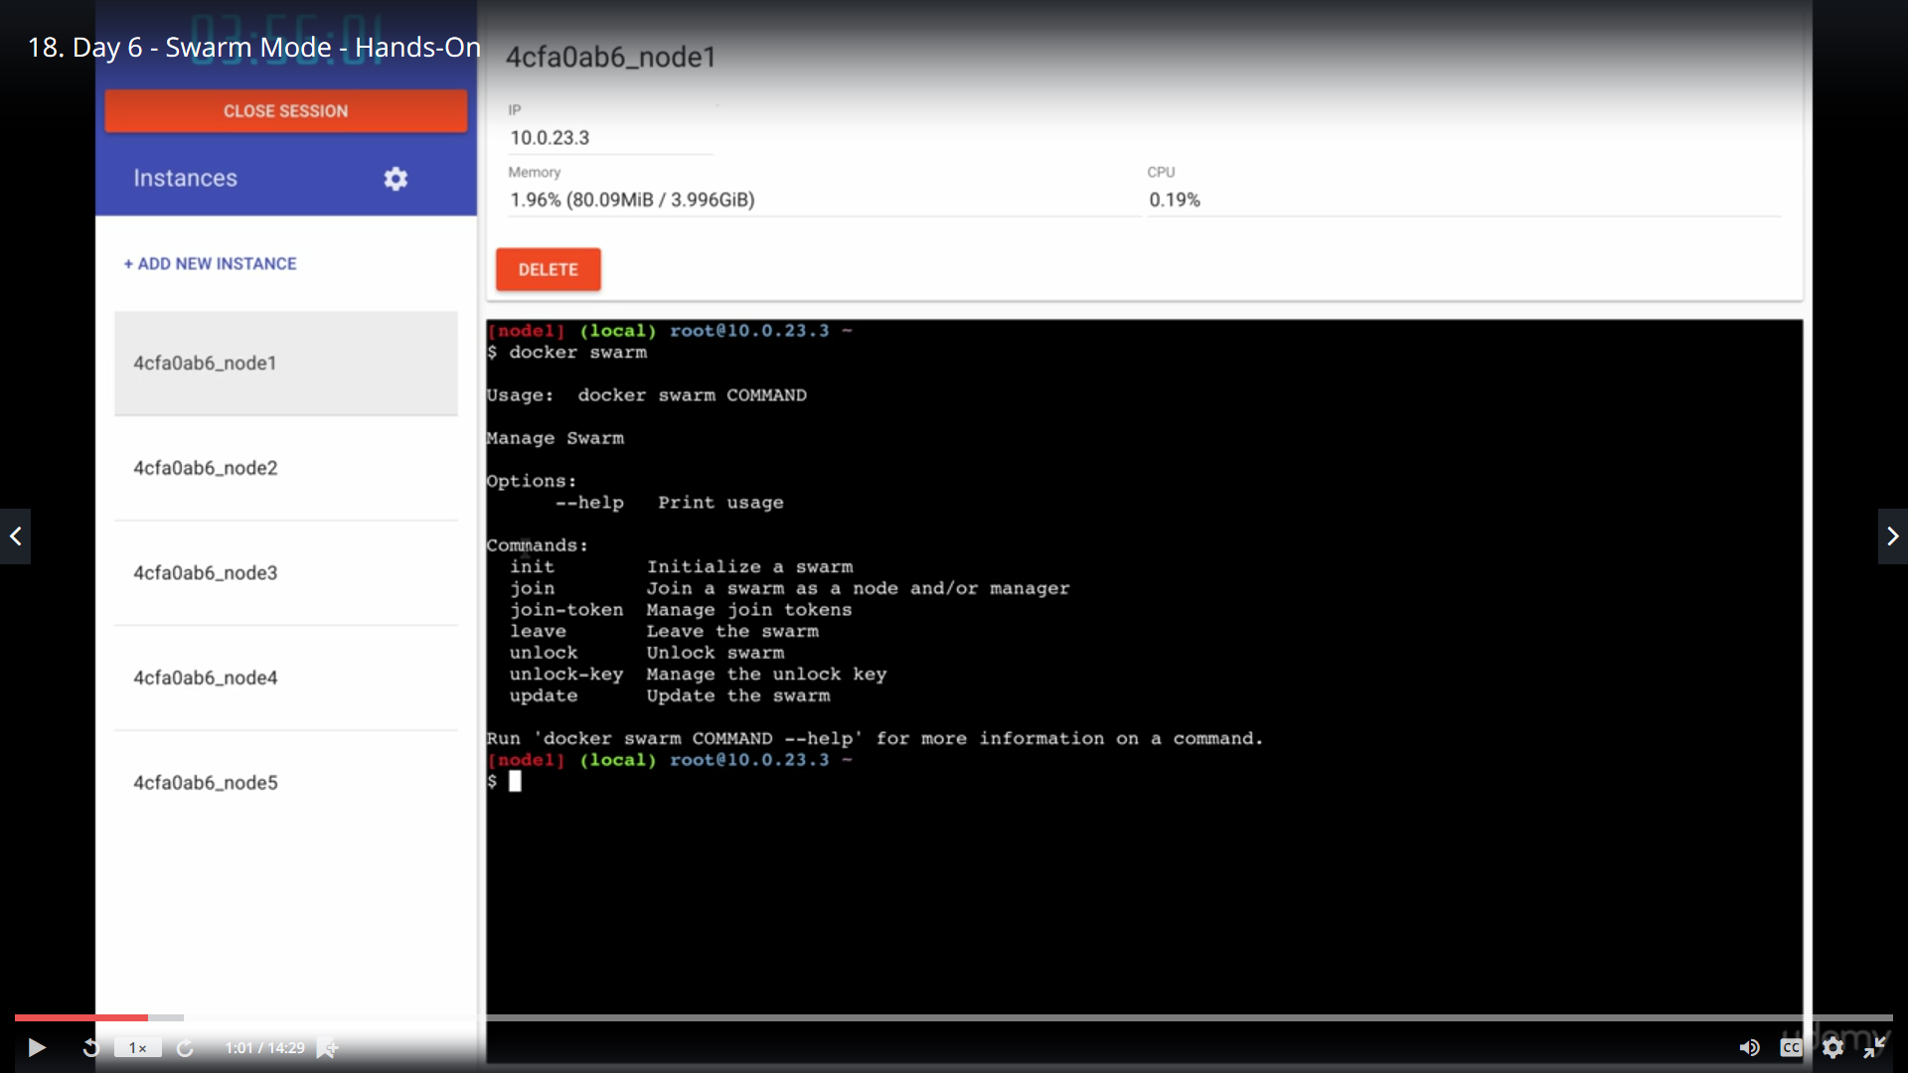

docker swarm init

**need to know ip address**

**note: if we have more than 1 ip difficult** 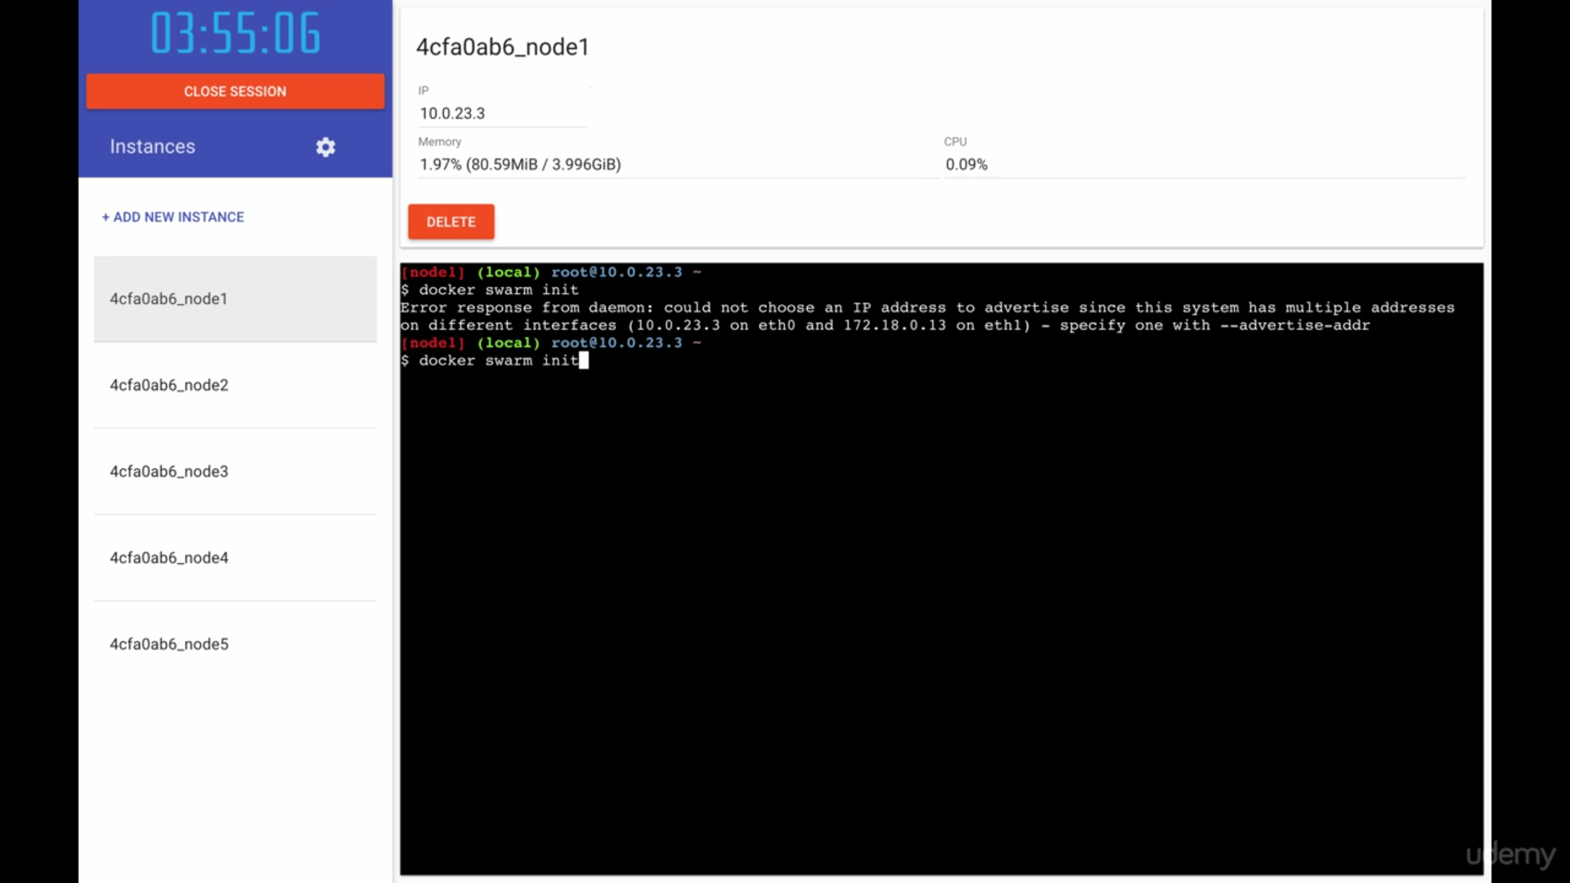

**use**

**ip a**

**use**

docker swarm init --advertise-address (HOST-IP)

docker swarm init --advertise-address 192.168.0.39

swarm has been set up for you

we will take 3 managers and 2 worker nodes

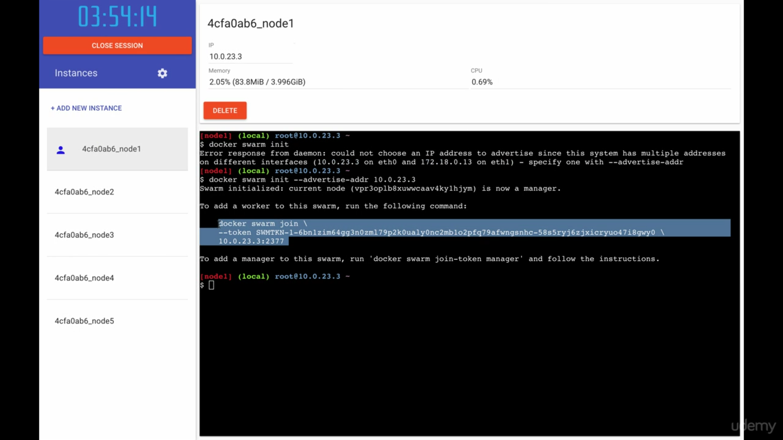

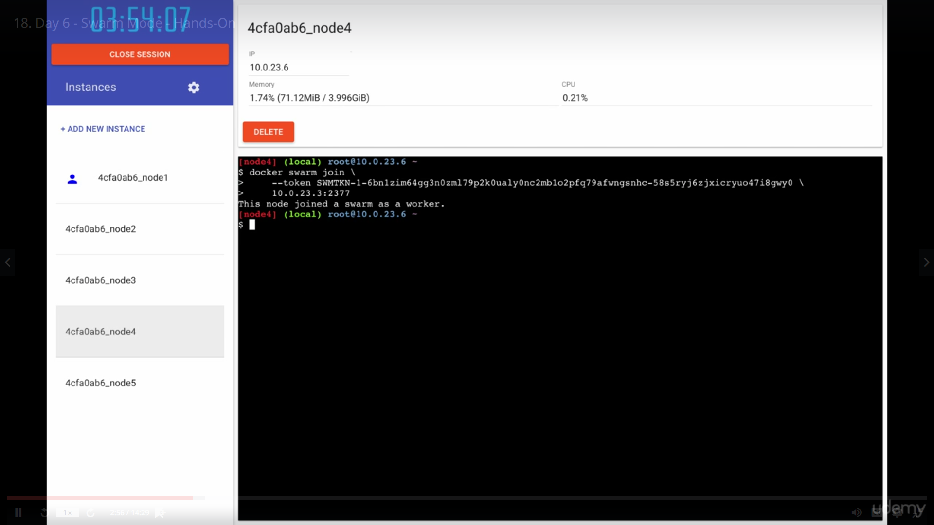

Copy that command in 4th and 5th instance for worker nodes

Check command in 1st manager:

docker node ls (run on only manager nodes)

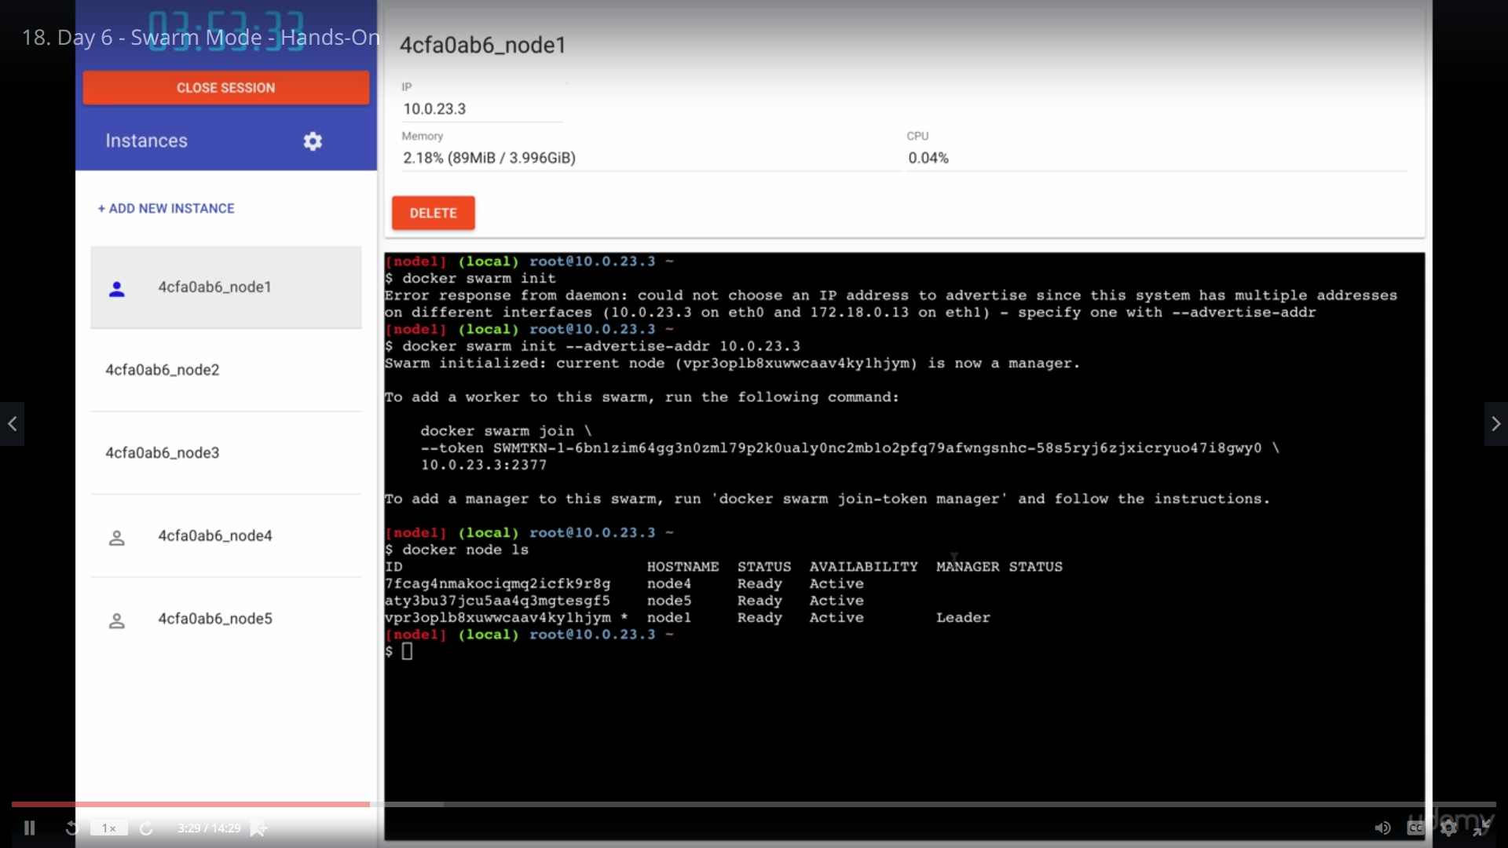

Make 2nd 3rd as managers

docker swarm join-token manager

to make others as manager

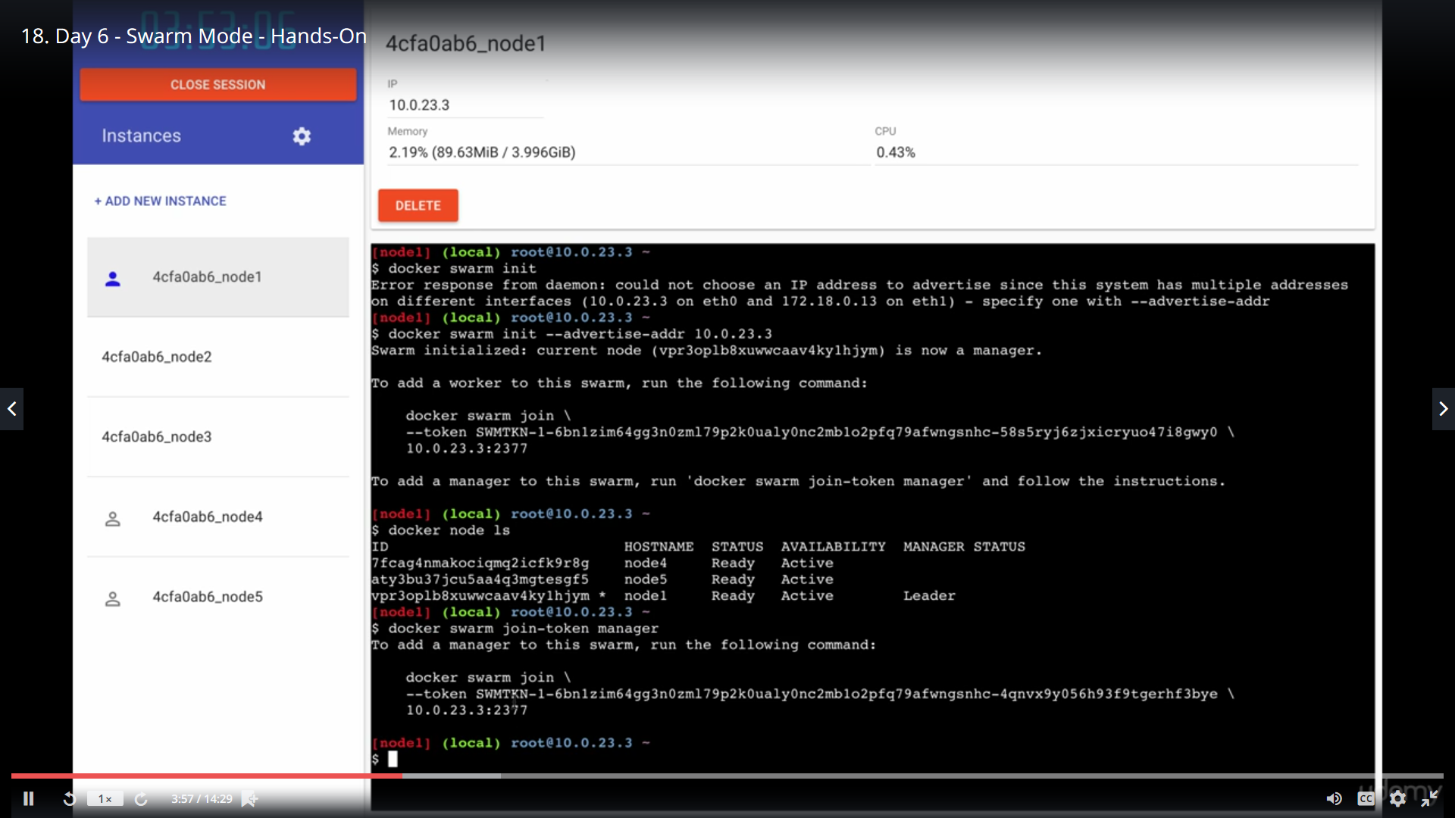

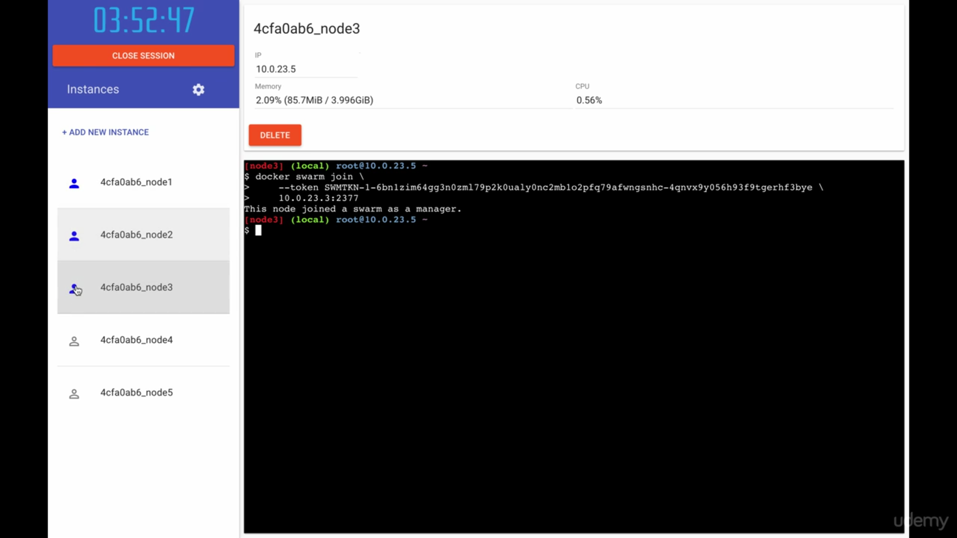

3 blues are managers and 2 are worker nodes

Docker node ls

We have swarm up and running

docker service create --name redis --replicas=8 redis

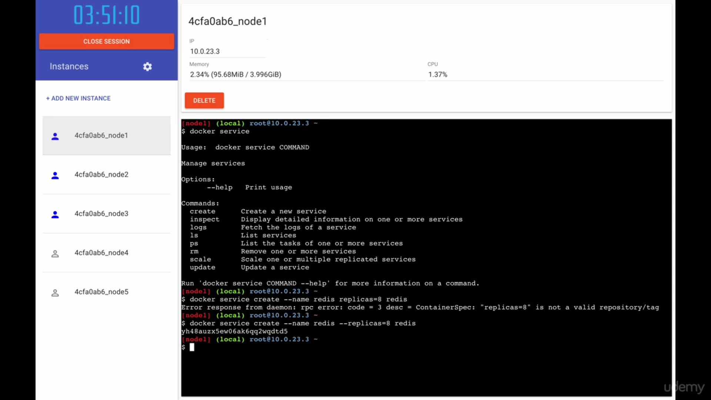

docker node ls

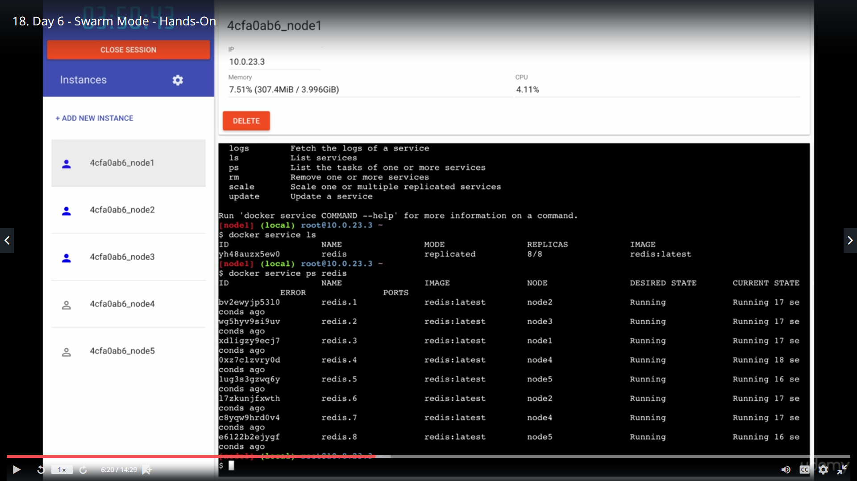

Docker service ps redis

8 containers spun up with 1 command

:

Goto 3th  instance manager : docker ps

Run docker ps on all instance and check

Update now:

docker service update --replicas=16 redis

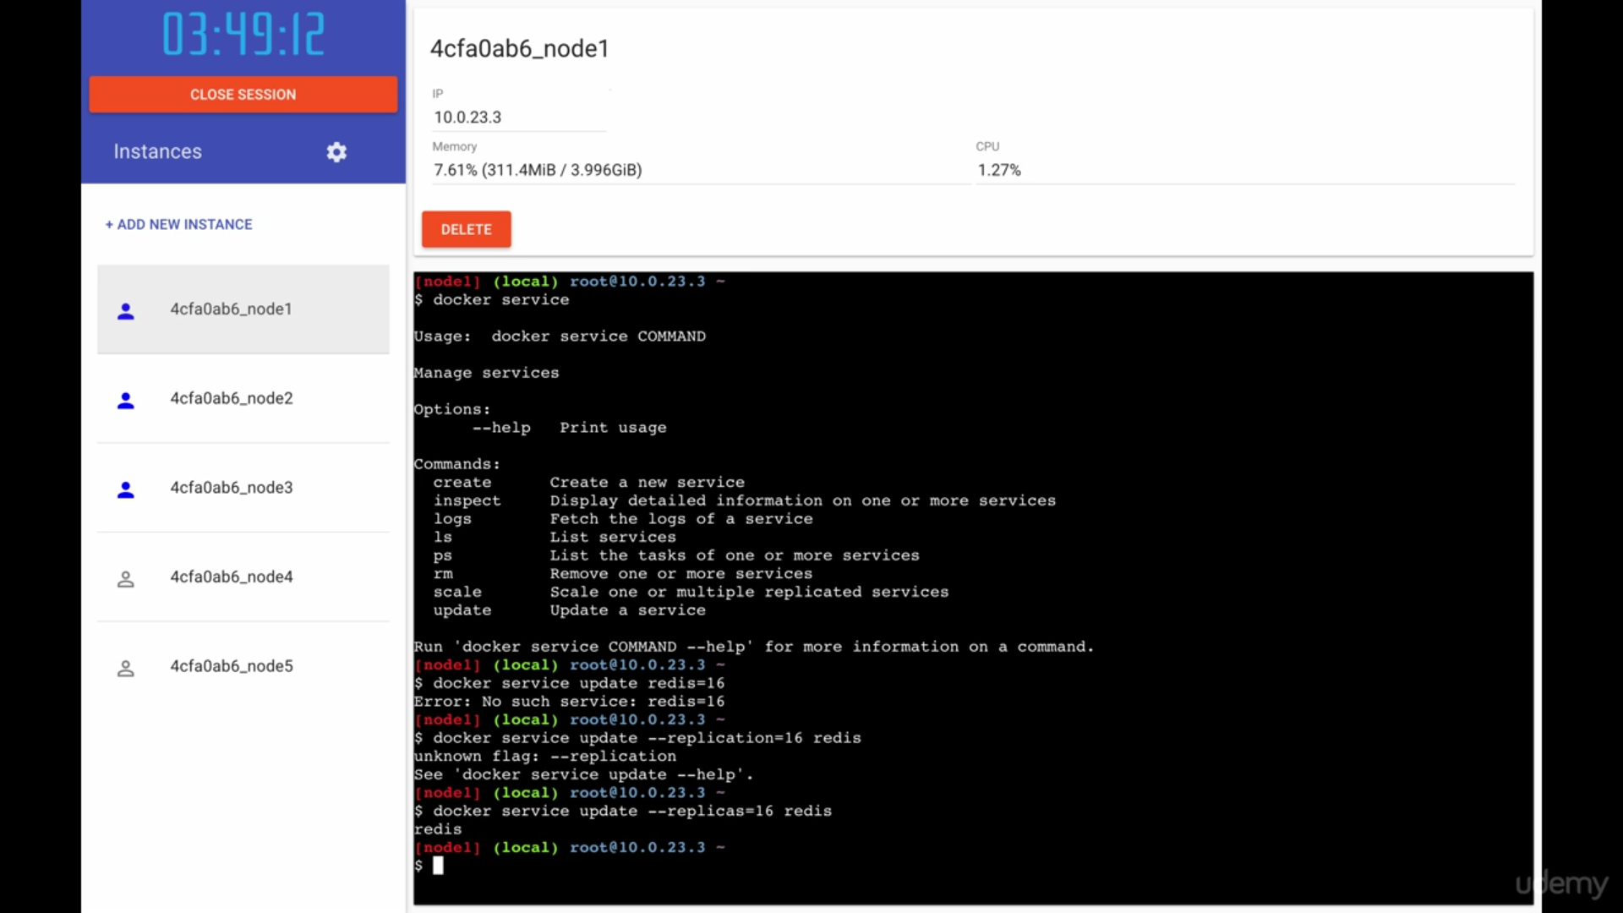

Docker service ls

docker service ls

docker service ps redis

: Now will see falut tolerant of oirchestration

In worker node: 5th instance:

Delete some

Docker kill $( docker ps -aq)

Docker ps (all the containers have been killed)

Docker ps ( all are up and running now☺

Docker ps

This is the beauty of orchestration

Go to: mgr 1:

Docker node ls

Docker service ls

What is one of the node goes down

Docker ps

Delete node by clicking del button

Think one of your severs gone or out of network

All of a sudden.

Now go to mgr and check

Docker service ls : 13/16

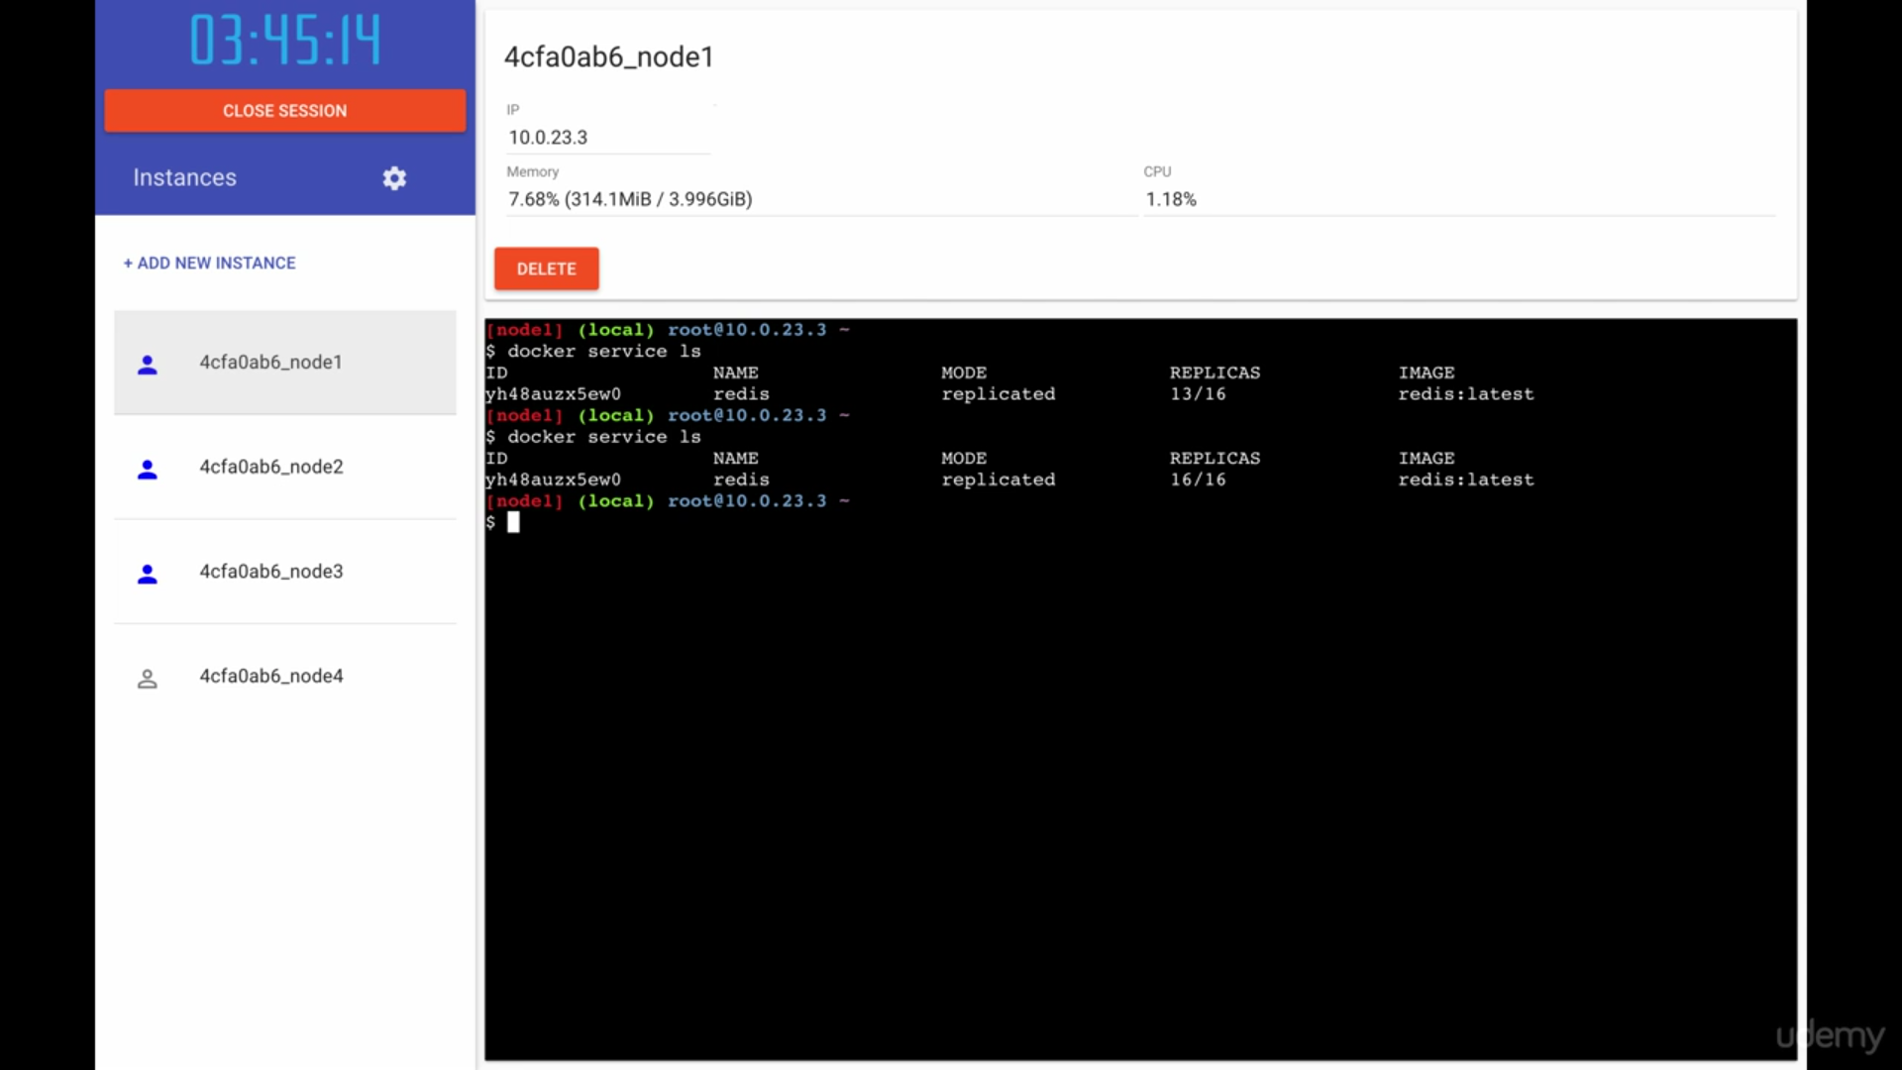

Now 16/16

Docker service ps redis

It brought up on diff node

It spun up neew containers on other nodes

Docker ps on all

This Is robust and fault tolerance system

03:

docker service create --name redis --replicas=11 redis

docker run -it -d -p 8080:8080 -v /var/run/docker.sock:/var/run/docker.sock manomarks/visualizer

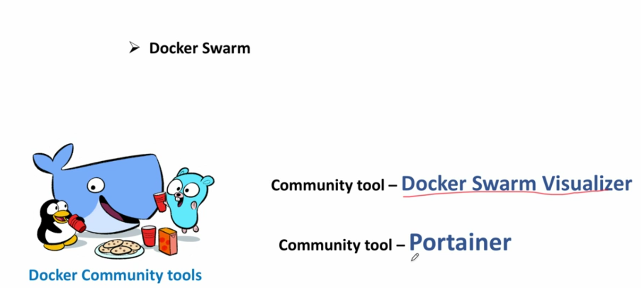

Docker node ls

docker service create --name redis --replicas=11 redis

docker service ls

docker service ps redis (which container is running where)

we are facing difficulty to find out which container is running where

<https://github.com/dockersamples/docker-swarm-visualizer>

docker run -it -d -p 8080:8080 -v /var/run/docker.sock:/var/run/docker.sock manomarks/visualizer

publish its port on 8080 port

downloads the visualizer on port 8080

docker service ps redis ( mgr1)

click on port 8080

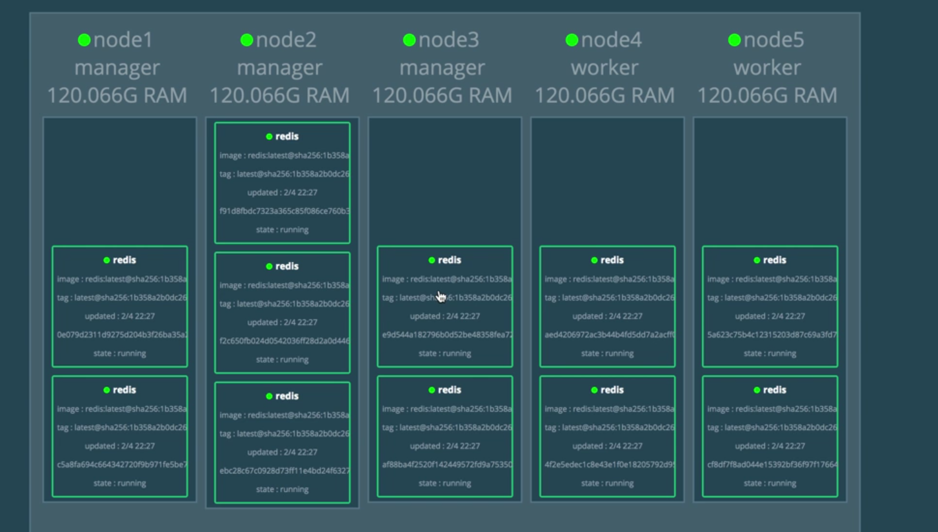

Now check orchestration

docker ps on all

docker kill $(docker ps -aq)

go to visualizer and check

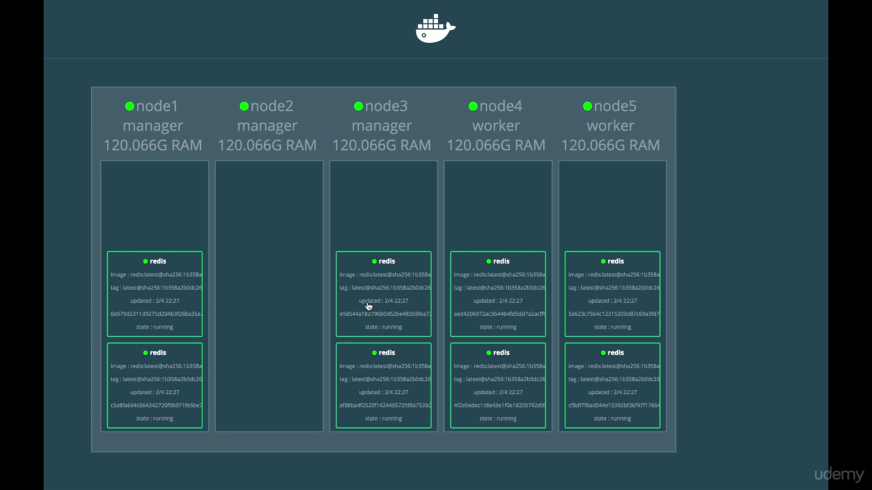

Again came up all containers

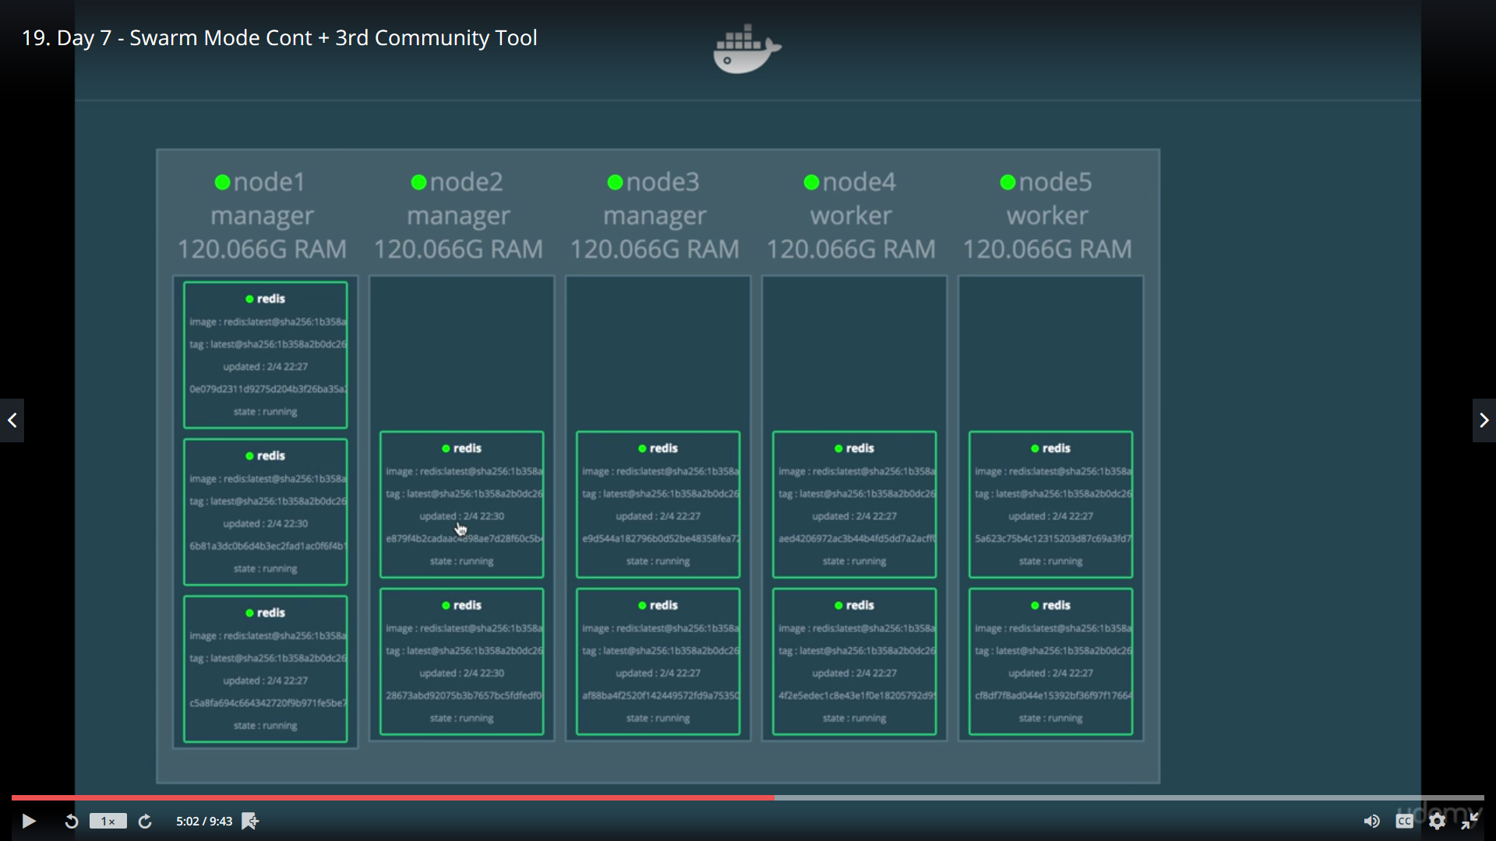

No we will bring down node itself

Delete

Worker node 4

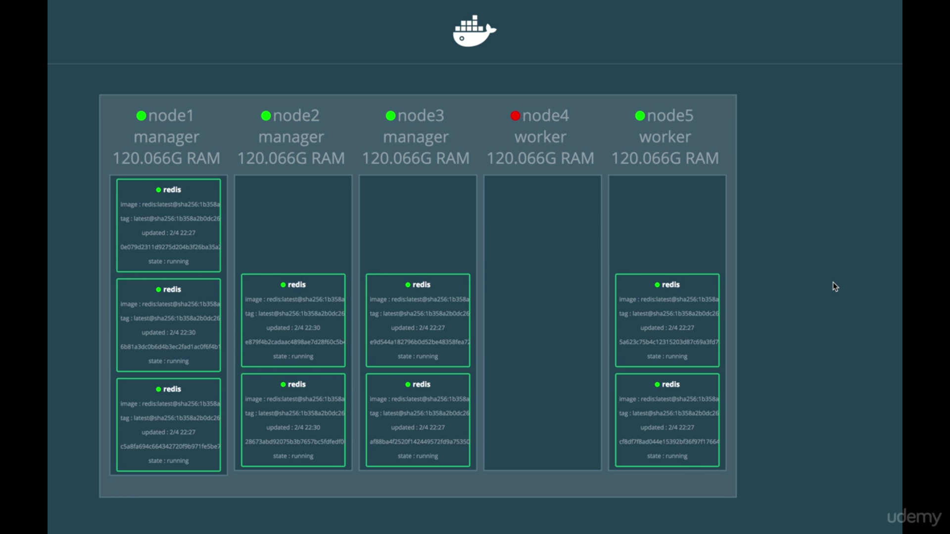

And container came up

We will work now with portainer site

Portainer.io

<https://www.portainer.io/>

docker run -d -p 9000:9000 portainer/portainer -H tcp:// 192.168.0.39:2375

click on 9000 port

create a pwd:

